10. Implementing transationd to ensure data integrity and consistency.(ise BEGINTRANSACTIONS/STARTTRACTION,COMMIT,ROLLBACK along with other sql queries).

start transaction;
commit;
rollback;
create database job1;
show databases;



use job1;
create table account4(
account_id int primary key,
name varchar(50),
balance decimal(10,2)
);

insert into account4 values
(1,'gauri',2000.00),
(2,'bhavana',500.00);
select*from account4;

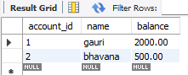

start transaction;
update account4
set balance=balance-500
where account_id=1;
select*from account4;

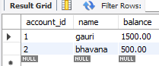

update account4
set balance=balance+200
where account_id=2;
select*from account4;
commit;

